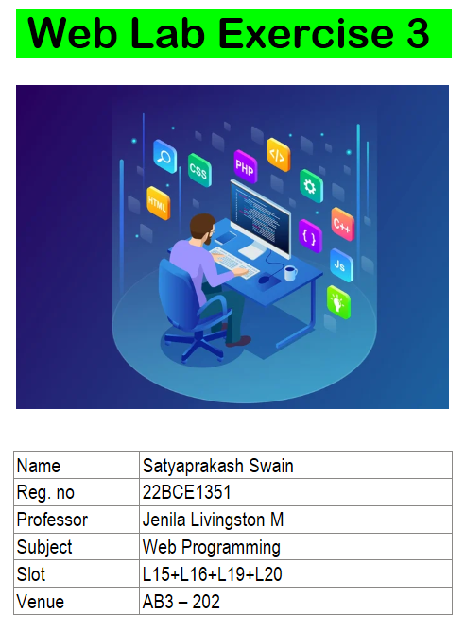

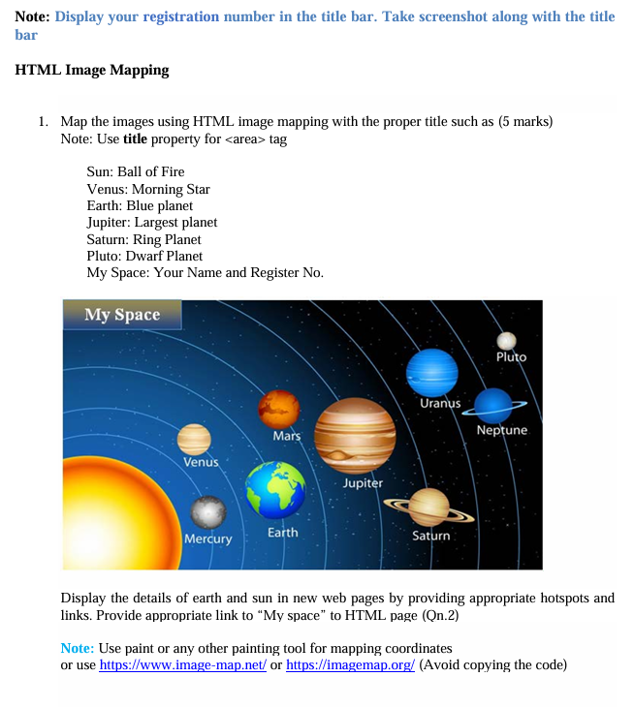

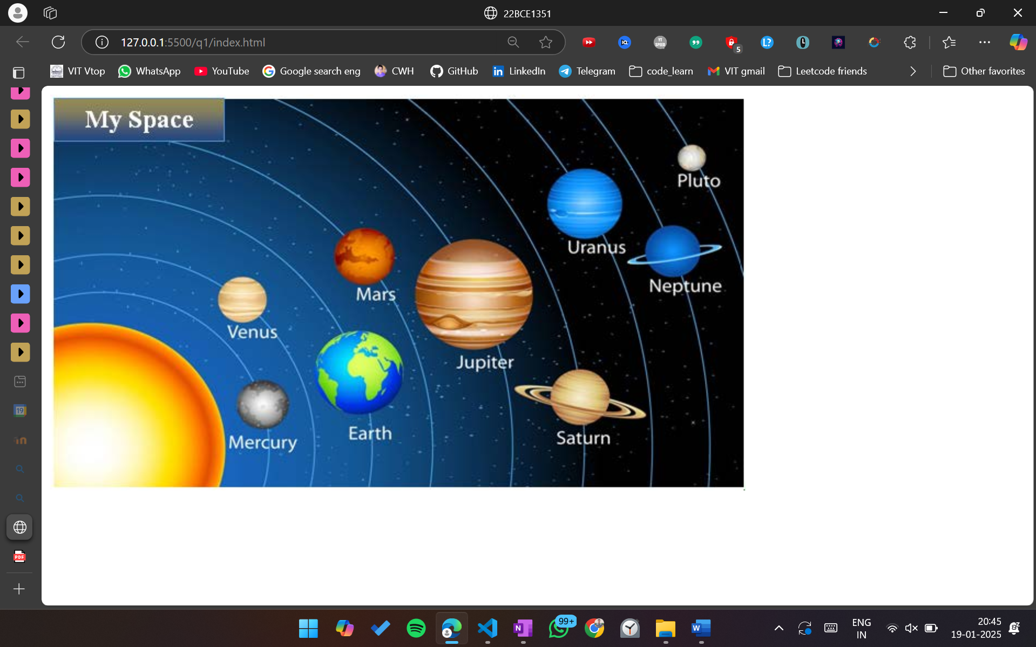

<!DOCTYPE html>

<html lang="en">

<head>

    <meta charset="UTF-8">

    <meta name="viewport" content="width=device-width, initial-scale=1.0">

    <title>22BCE1351</title>

</head>

<body>

    <img src="space.png" alt="Solar System Image" usemap="#image-map">

    <map name="image-map">

        <area target="_blank" alt="satyaprakash swain 22BCE1351" title="satyaprakash swain 22BCE1351" href="../q2/myspace.html" coords="160,42,4,2"

            shape="rect">

        <area target="_blank" alt="" title="Ball of Fire" href="sun.html" coords="40,326,118" shape="circle">

        <area target="_blank" alt="Morning Star" title="Morning Star" href="" coords="174,188,21" shape="circle">

        <area target="_blank" alt="Blue planet" title="Blue planet" href="earth.html" coords="280,254,43" shape="circle">

        <area target="_blank" alt="Largest planet" title="Largest planet" href="" coords="385,183,54" shape="circle">

        <area target="_blank" alt="Ring Planet" title="Ring Planet" href="" coords="481,281,27" shape="circle">

        <area target="_blank" alt="Dwarf Planet" title="Dwarf Planet" href="" coords="586,56,12" shape="circle">

    </map>

</body>

</html>

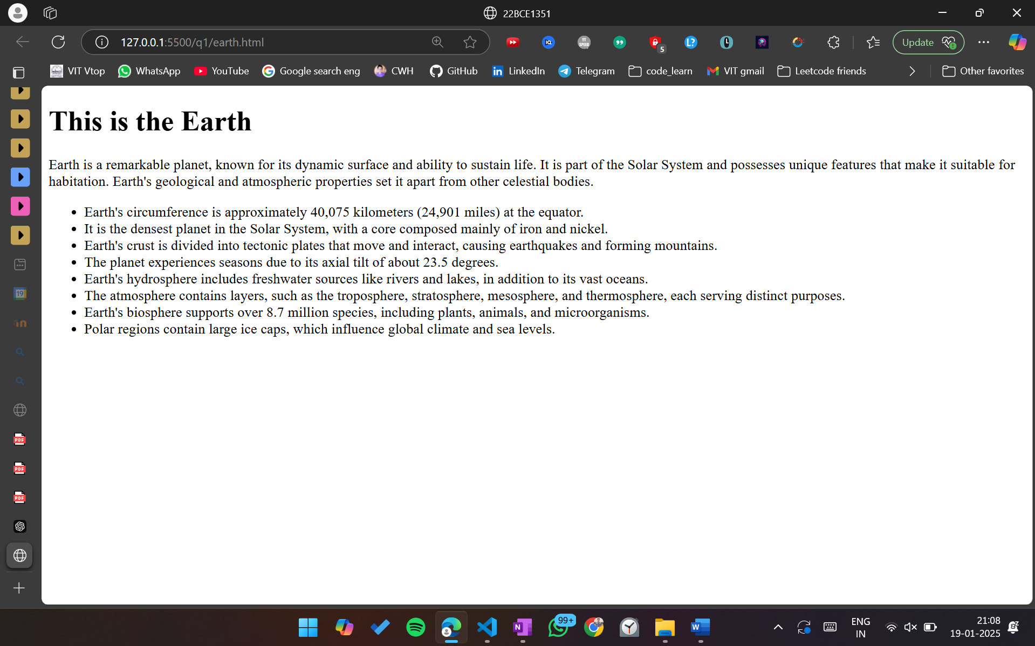

<!DOCTYPE html>

<html lang="en">

<head>

    <meta charset="UTF-8">

    <meta name="viewport" content="width=device-width, initial-scale=1.0">

    <title>22BCE1351</title>

</head>

<body>

    <h1>This is the Earth</h1>

    <p>Earth is a remarkable planet, known for its dynamic surface and ability to sustain life. It is part of the Solar System and possesses unique features that make it suitable for habitation. Earth's geological and atmospheric properties set it apart from other celestial bodies.</p>

    <ul>

        <li>Earth's circumference is approximately 40,075 kilometers (24,901 miles) at the equator.</li>

        <li>It is the densest planet in the Solar System, with a core composed mainly of iron and nickel.</li>

        <li>Earth's crust is divided into tectonic plates that move and interact, causing earthquakes and forming mountains.</li>

        <li>The planet experiences seasons due to its axial tilt of about 23.5 degrees.</li>

        <li>Earth's hydrosphere includes freshwater sources like rivers and lakes, in addition to its vast oceans.</li>

        <li>The atmosphere contains layers, such as the troposphere, stratosphere, mesosphere, and thermosphere, each serving distinct purposes.</li>

        <li>Earth's biosphere supports over 8.7 million species, including plants, animals, and microorganisms.</li>

        <li>Polar regions contain large ice caps, which influence global climate and sea levels.</li>

    </ul>

</body>

</html>

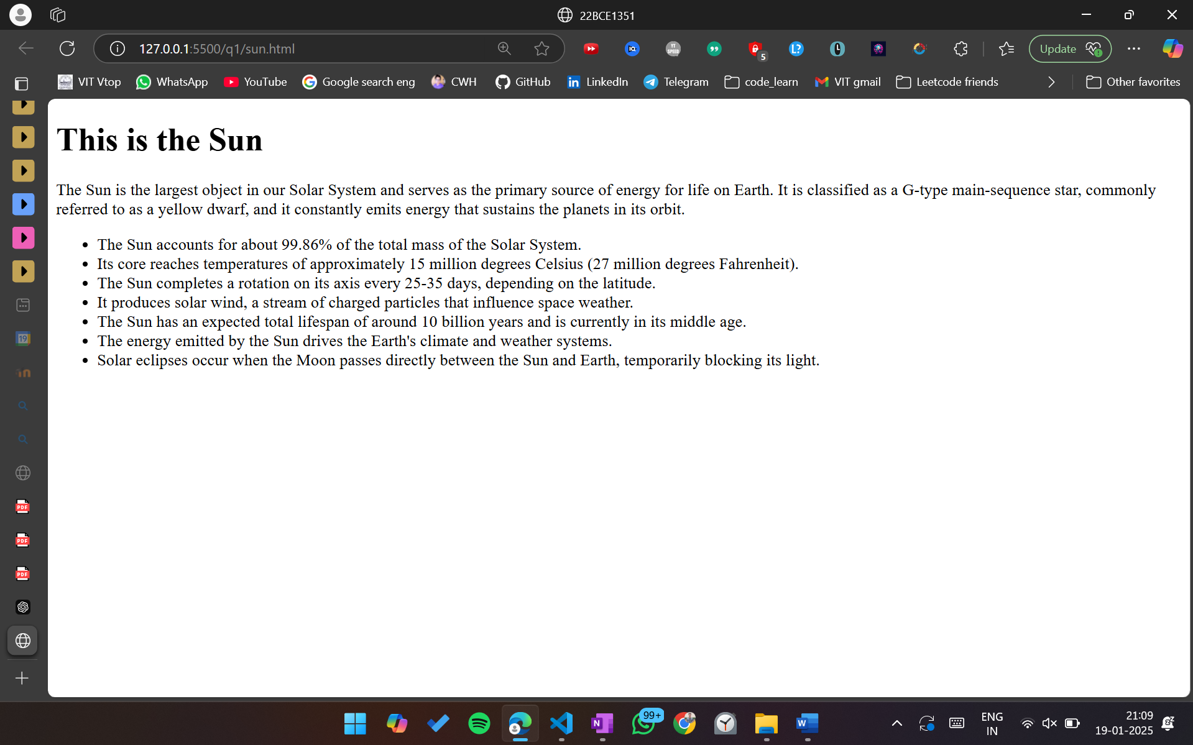

<!DOCTYPE html>

<html lang="en">

<head>

    <meta charset="UTF-8">

    <meta name="viewport" content="width=device-width, initial-scale=1.0">

    <title>22BCE1351</title>

</head>

<body>

    <h1>This is the Sun</h1>

    <p>The Sun is the largest object in our Solar System and serves as the primary source of energy for life on Earth. It is classified as a G-type main-sequence star, commonly referred to as a yellow dwarf, and it constantly emits energy that sustains the planets in its orbit.</p>

    <ul>

        <li>The Sun accounts for about 99.86% of the total mass of the Solar System.</li>

        <li>Its core reaches temperatures of approximately 15 million degrees Celsius (27 million degrees Fahrenheit).</li>

        <li>The Sun completes a rotation on its axis every 25-35 days, depending on the latitude.</li>

        <li>It produces solar wind, a stream of charged particles that influence space weather.</li>

        <li>The Sun has an expected total lifespan of around 10 billion years and is currently in its middle age.</li>

        <li>The energy emitted by the Sun drives the Earth's climate and weather systems.</li>

        <li>Solar eclipses occur when the Moon passes directly between the Sun and Earth, temporarily blocking its light.</li>

    </ul>

</body>

</html>

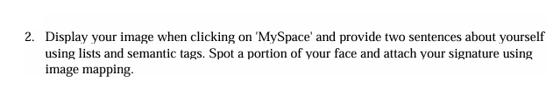

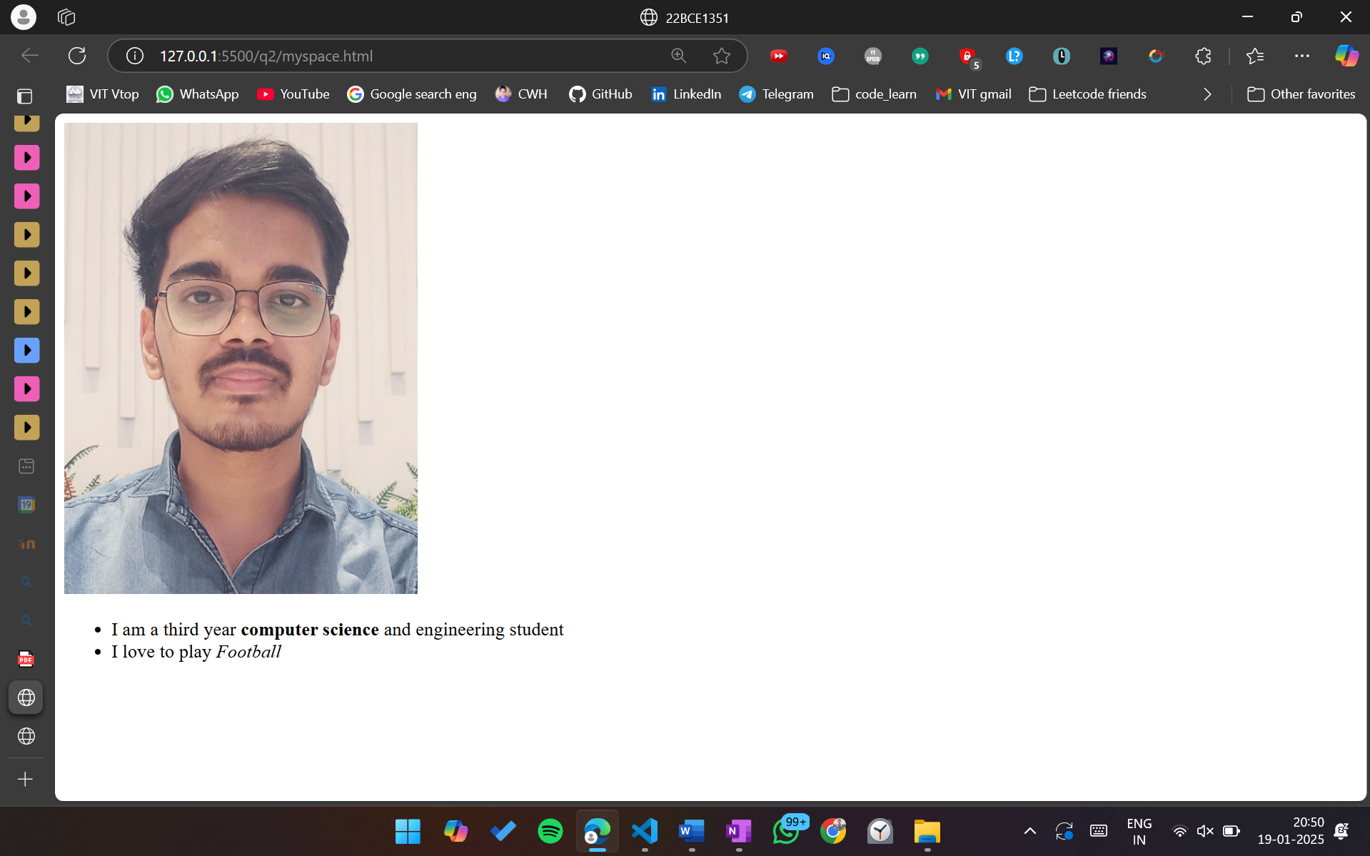

<!DOCTYPE html>

<html lang="en">

<head>

    <meta charset="UTF-8">

    <meta name="viewport" content="width=device-width, initial-scale=1.0">

    <title>22BCE1351</title>

</head>

<body>

    <img src="my-passport-photo.jpg" usemap="#image-map" height="400vw">

    <map name="image-map">

        <area target="_blank" alt="satyaprakash swain" title="satyaprakash swain" href="sig.html" coords="176,298,113,302,76,116,193,113,224,213,219,229,205,245,196,275" shape="poly">

    </map>

    <ul>

        <li>I am a third year <strong>computer science</strong> and engineering student</li>

        <li>I love to play <em>Football</em></li>

    </ul>

</body>

</html>

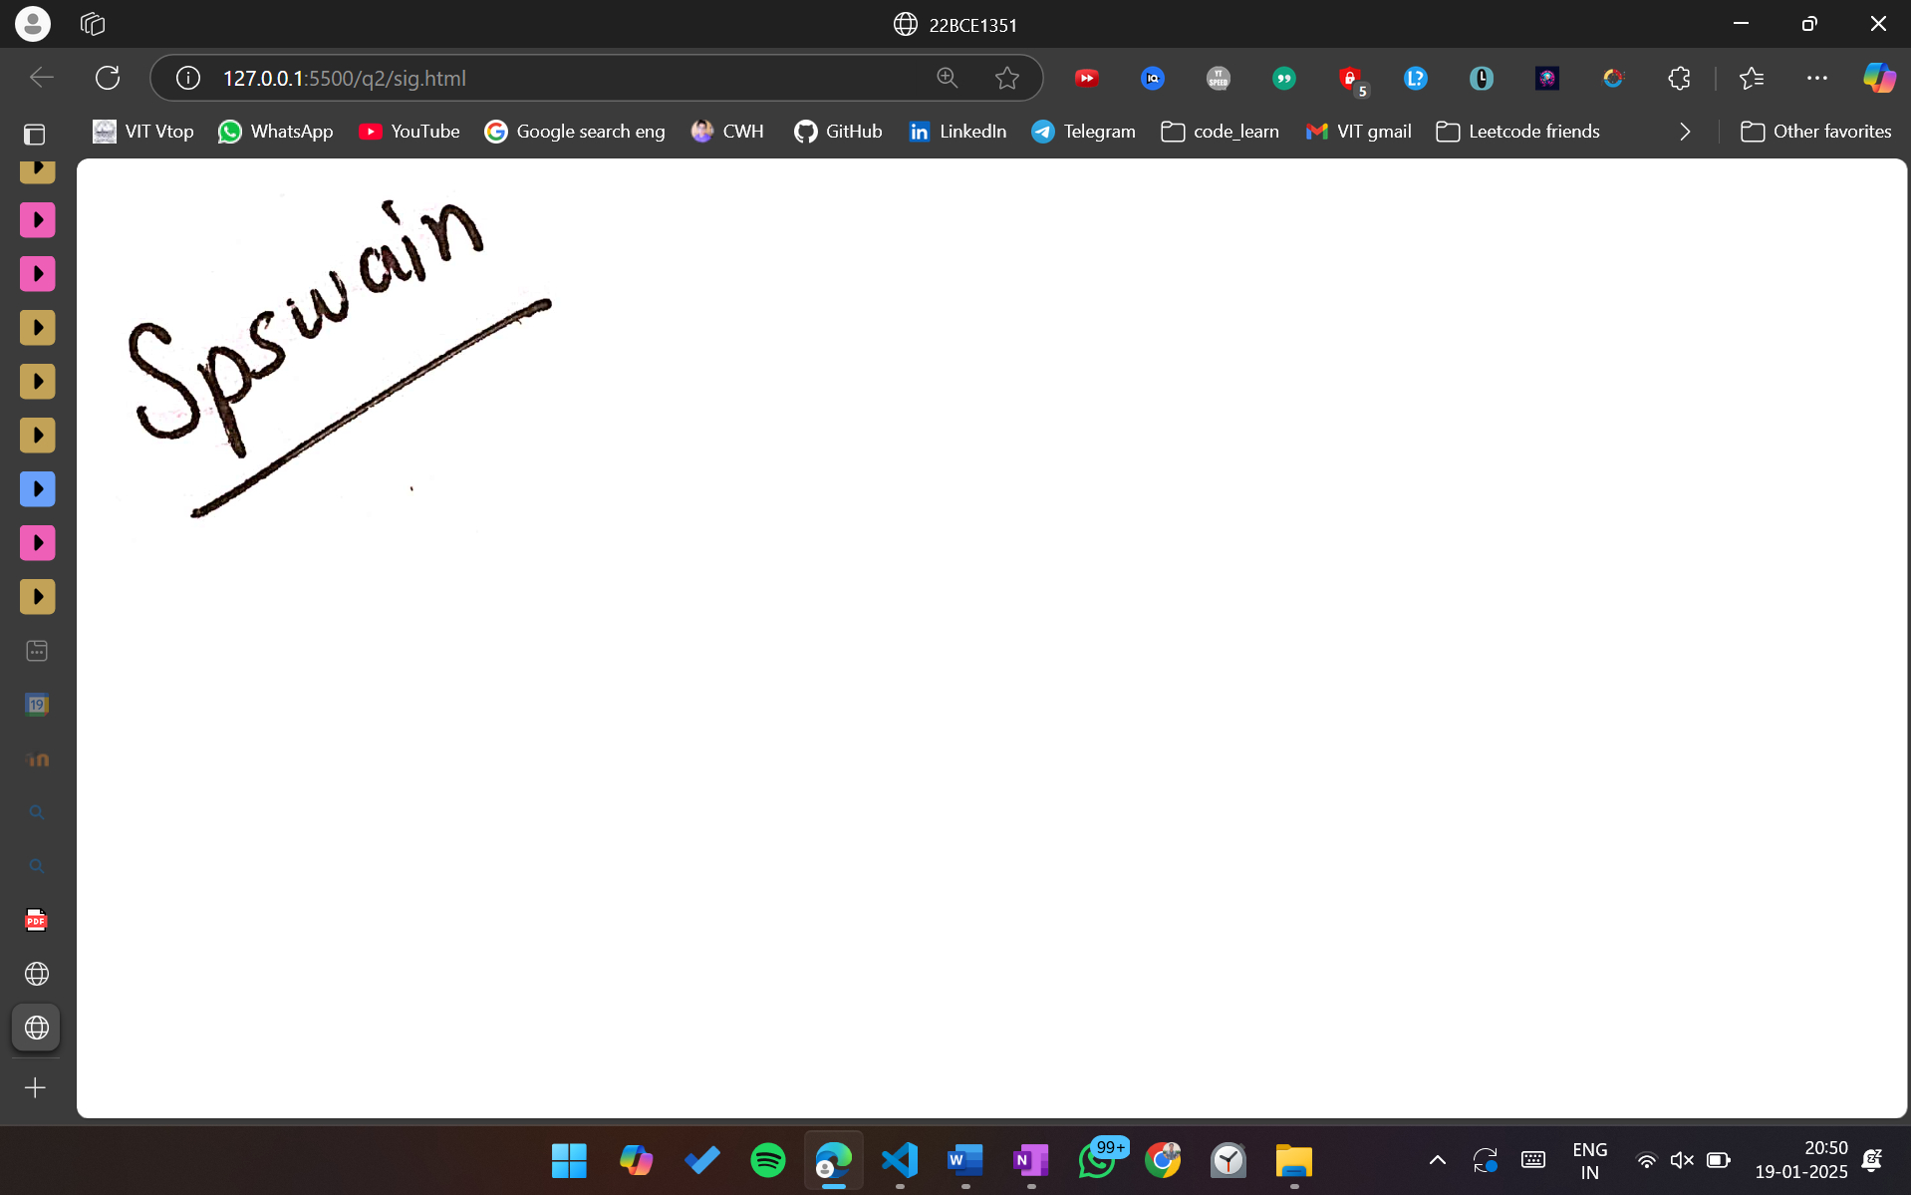

<!DOCTYPE html>

<html lang="en">

<head>

    <meta charset="UTF-8">

    <meta name="viewport" content="width=device-width, initial-scale=1.0">

    <title>22BCE1351</title>

</head>

<body>

    <img src="my_sig.jpg" alt="Signature" width="300">

</body>

</html>

